MACHINE LEARNING-BASED MIXED REFRIGERANT OPTIMIZATION TO REDUCE COMPRESSION POWER AND FUEL GAS CONSUMPTION IN BADAK LNG

Mukhammad Yusuf Iqbal^{1*}, Wiko Bagus Oka², Arifda Aldyano³.
^{1*}Mechanical Engineering, ²Mechanical Engineering, ³Mechanical Engineering.
Email: mukhammad.yusuf.iqbal.tm23@stu.pnj.ac.id

Abstract-Mixed-refrigerant (MR) composition and flow rate strongly affect energy consumption of propane-precooled mixed-refrigerant (C3MR) LNG liquefaction. Comparing baseload and underload operation (from 2025 until 2026) at Badak LNG Train-H, shows that treated-gas flow rate is 53.5% lower (399.74 to 185.82 t/h), while MR flowrate is 26.0% lower (681.4 to 504 t/h), the specific energy consumption (SEC) is 49.2% higher (350.49 to 523 kWh/t_{LNG}). This flow mismatch, together with the effect of MR composition on compressor power demand (resulted as SEC), highlights the need to optimize both variables. Although previous studies demonstrated energy optimization, the applicability of ML-based MR optimization across varying loads under Badak LNG’s actual data and constraints such as specific equipment (flow_{compressor surge limit} > 480 t/h; main cryogenic heat exchanger ΔP < 0.35 kg/cm²) and process trade-off (mismatch MR and gas flow; MITA > 1.5ºC; Temperature_{1st compressor suction} > -45ºC;) remains insufficiently established. To address these gaps, this study develops a plant-specific physics-informed ML optimization framework (simulation-based compressor shaft speed achieved R² up to 0.9945, while the historian data-based achieved an R² up to 0.8419.), constraining optimized candidates within the 95% trust operating envelope using Mahalanobis distance (D_{M}), evaluated by Aspen Hysys. Across the operating envelope, the framework identifies an optimal MR composition (3.77% N₂, 42.22% CH₄, 43.67% C₂H₆, 1.53% C₂H₄, 8.82% C₃H₈) within the 95% trust envelope (D_{M} = 1.2723 ≤ 3.0802). Optimization adjusted MR flow rate (baseload to 769.7 t/h; underload to 604.7 t/h), cut specific energy consumption (SEC) (baseload to 256.51 kWh/t_{LNG}; underload to 339.89 kWh/t_{LNG}), and decreased fuel gas consumption (baseload from 47,281.92 to 44,189.71 Nm³/h; underload from 34,605.34 to 33,853.05 Nm³/h), consequently cut CO₂ emission (baseload from 100.79 to 94.20 t/h; underload from 73.77 to 72.16 t/h). This optimization saves 2,382,720 USD/year (underload Badak LNG Train-H capacity) up to 9,793,680 USD/year (baseload Badak LNG Train-H capacity).

Keywords: Liquefied Natural Gas, C3MR Liquefaction, Machine Learning, Mixed Refrigeration Optimization, Energy Efficiency

- INTRODUCTION

Natural gas liquefaction requires large amounts of energy because natural gas must be cooled to -162ºC to produce liquefied natural gas (LNG), enabling its long-distance transport (Barbazza, 2024; Wu et al., 2025). The baseline C3MR process accounts for 30-40% of an LNG plant's energy consumption, the mixed refrigerant (MR) removes heat from natural gas inside the Main Cryogenic Heat Exchanger (MCHE). Mismatched refrigerant composition and flow rate can affect the C3MR performance and require more energy to produce LNG (Shady et al., 2024). Improving refrigeration efficiency can reduce operating costs and greenhouse-gas emissions, supporting Indonesia’s Enhanced NDC target of a 31.89% unconditional emissions reduction by 2030 and its net-zero ambition by 2060 or earlier (Republic of Indonesia, 2022), alongside the country’s carbon-pricing framework established under Presidential Regulation No. 98 of 2021 (Republic of Indonesia, 2021).
At PT Badak NGL, the plant was originally designed to process rich gas with approximately 85% methane, but has received leaner feed gas containing more than 89% methane since 2017 (Purwanugraha, 2023). This change has introduced challenges involving decreasing plant thermal efficiency (figure 1.1), LNG quality, C₂ and C₃ (LPG) availability for refrigerant makeup, and energy consumption (Ahmad et al., 2022; PT Badak NGL; 2021). The operational challenge is also reflected on historical data between 2025–2026. Comparing baseload and underload, treated-feed flow is 53.5% lower, from 399.7 to 185.8 $kNm^{3}/h$ (or LNG rundown flow from 308.3 to 141.2 t/h). Strangely, MR flow is only 26.0% lower, from 681.4 to 504.0 t/h, while specific energy consumption (SEC) increases by 49.2%, from 350.5 to 523.0 $kWh/t_{LNG}$. This difference shows that MR flow does not decrease in proportion to feed throughput as production falls (Wang, 2023). This mismatch highlights the need to adjust mixed refrigerant flow rate and composition while maintaining MCHE cooling performance and compressor operating limits. (Alimardani et al., 2024).

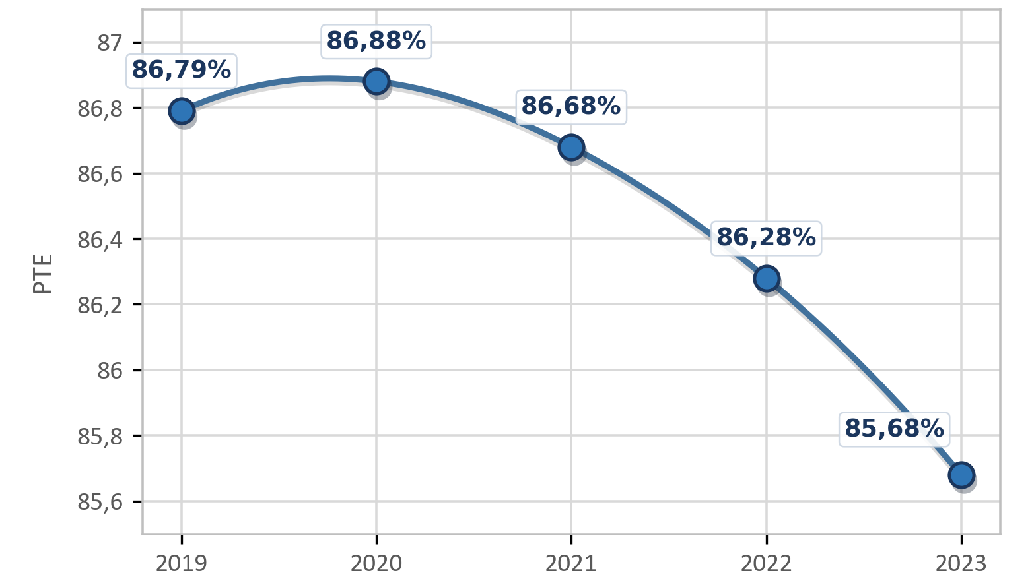
Figure 1.1 Plant thermal efficiency (PT Badak NGL, 2021)

Existing optimization studies fall into three groups, each with a limitation. Simulation-based optimization has reduced compression power by 9-15%, using metaheuristics (Alabdulkarem et al., 2011; Wu et al., 2025) or knowledge-based and Bayesian methods (Shady et al., 2024), but its feasible region is set by the simulator and equipment limits rather than by conditions a plant has demonstrated. Machine-learning surrogates speed up the search (Alimardani et al., 2024; Sial et al., 2026), yet they are trained on simulation data, and unconstrained predictions can be physically infeasible; only 18.5% of cases in Alimardani et al. (2024) were valid. Models trained on plant data capture real behavior, but operational data cover a narrow range and predictions degrade outside it (Daoutidis et al., 2024), with test-set R² of tree-based models as low as 0.32-0.39 in a compressor case (Li et al., 2026). There’s no published study that combines plant historian data, a statistically defined operating envelope, and thermodynamic verification to optimize the MR composition of an operating C3MR plant.
Filling these gaps, this study develops a plant-specific framework to optimize MR composition and flow rate at PT Badak NGL Train H across different production loads. The framework combines machine-learning models trained on operating data, statistical screening using the isometric log-ratio (ILR) transformation and Mahalanobis distance, and process simulation in Aspen HYSYS. Candidate solutions are evaluated against minimum 1st stage MR compressor flow (>480 t/h), 1st stage MR compressor suction temperature (> -45ºC), minimum internal temperature approach (MITA) (> 1.5ºC), and main cryogenic heat exchanger delta pressure < 0.35 kg/cm² (PT Badak NGL, 2024). By combining plant data with statistical screening and thermodynamic evaluation, the machine learning framework aims to identify suitable MR operating conditions for different production loads while accounting for the constraints of the existing equipment.

- METHODOLOGY

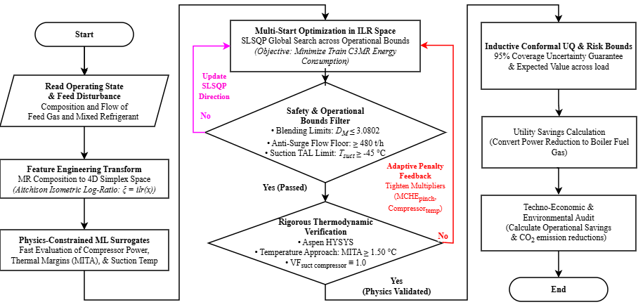
Figure 2.1 Research methodology for mixed refrigerant optimization

This study develops a data-driven framework for optimizing MR flow rate and composition in PT Badak NGL Train H through historical-data screening, surrogate modeling, constrained optimization, and thermodynamic and techno-economic assessment (Figure 2.1). The system boundary includes the propane refrigeration loop, MR circuit, compressor drivers, and MCHE 5E-1 (Appendix 6.1).

2.1 Process Description and Baseline Data Preprocessing

Badak LNG uses a propane-precooled mixed-refrigerant (C3MR) process. Propane precools the treated feed gas and MR, while the liquid and vapor fractions of MR provide cooling at different temperature levels in the MCHE. After expansion and heat absorption, the vaporized refrigerant returns to the compressor circuit. MR composition and flow rate therefore provide the principal optimization variables for evaluating refrigeration performance and compressor energy demand as shown on figure 2.2 (Badak LNG, 2024).

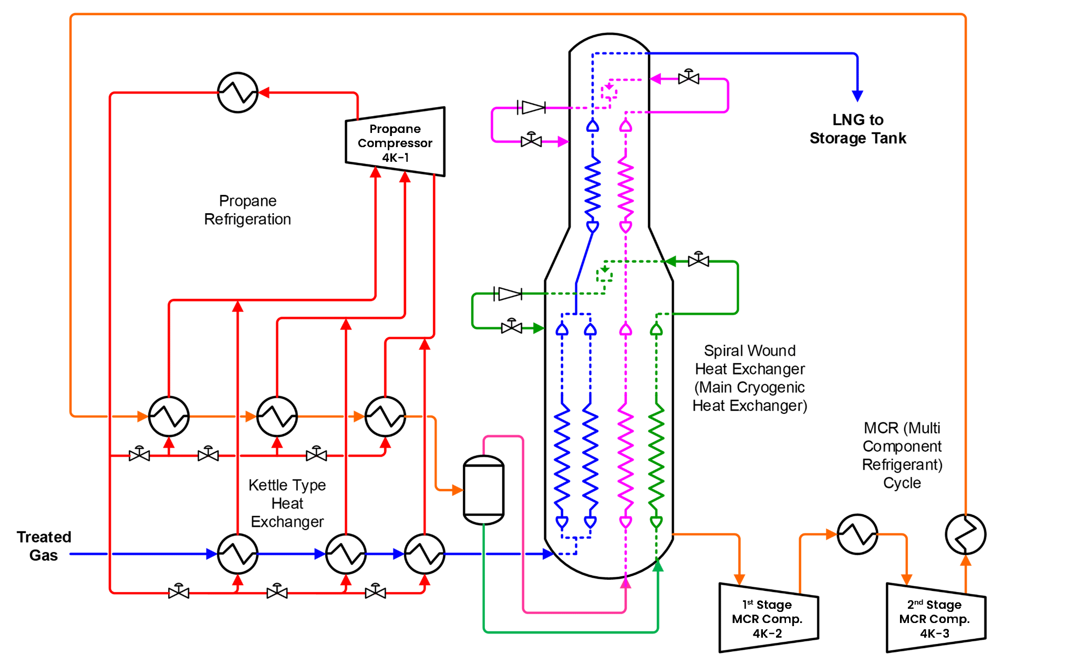
Figure 2.2 Process flow design of Badak LNG’s liquefaction unit

Badak LNG’s historian data contained 720,734 one-minute records from 2025-2026.. After excluding startup, shutdown, or idle records with LNG rundown ≤ 50 t/h, 110,137 records were retained for baseline analysis. Further steady-state screening for surrogate development retained 67,916 records that met the specified feed-flow, LNG-production, MR-circulation, suction-temperature, compressor-power, and driver-steam criteria. Seven representative operating points (P10, P25, P40, P50, P60, P75, and P90) were then selected from the baseline data using the medoid method, preserving combinations of process conditions recorded during actual plant operation (Teichgraeber & Brandt, 2019; Wicaksana et al., 2026).

2.2 Machine Learning Model Development

The MR composition is treated as compositional data because the component mole fractions defined in section 2.2 are constrained to 100%mol and stated as an equation 1.
$x_{mixed refrigerant}=[x_{N2},x_{CH4},x_{C2H6},x_{C2H4},x_{C3H8}]=1$ …………………………….(1)
The composition vector is transformed into isometric log-ratio coordinates before optimization and operating-domain screening in equation (2). where z is the four-dimensional ILR coordinate vector and V is the orthonormal basis matrix. The transformation converts MR composition as four log-ratio coordinates, avoiding the constant-sum dependence among the original mole fractions.
$z=ilr(x_{MR})=V^{T}ln(x_{MR})$ …………………………………………………(2)
HistGradientBoostingRegressor (HGBR) was selected as the surrogate model because it can capture nonlinear relationships between MR composition, circulation rate, process conditions, and compressor power while efficiently processing large datasets through histogram-based tree construction (Grinsztajn et al., 2022). In this study, HGBR was used as a screening surrogate of compressor shaft speed to rank candidate MR compositions and flow rates. Specific energy consumption (SEC), the primary energy-performance indicator, was then calculated for the selected candidate from the Aspen HYSYS simulation. Consistent with PT Badak NGL’s ISO 50001 energy management system, SEC was defined as the ratio of total shaft power from compressor drivers 4KT-1, 4KT-2, and 4KT-3 to LNG production rate (Clean Energy Ministerial, 2024), as expressed in Equation (3). The SEC is defined as the ratio of total compressor power (P_{shaft}) to the mass flow rate of natural gas (ṁ_{LNG}) (equation 3).
$SEC (kWh/t_{LNG})=\frac{P_{4K1}+P_{4K2}{+P}_{4K3} (kW)}{ṁ_{LNG} (t/h)}$ ……………………………………….(3)

2.3 Optimization and Thermodynamic Validation

The optimization objective is minimizing ML-predicted specific energy consumption $(\hat{SEC})$, by varying MR composition and MR flow rate while maintaining the specified feed-gas and production conditions. The optimization objective is expressed as equation 4.
$Minimize \hat{SEC} =f(x_{MR},ṁ_{MR},u)$ …………………..……………….………(4)
where $\hat{SEC}$ is the ML-predicted specific energy consumption (kWh/t_{LNG}), x_{MR} ​ is the MR composition vector, ṁ_{MR} ​ is the MR flow rate (t/h), and $u$ represents the fixed process-input vector, including feed-gas flow rate, inlet pressure, inlet temperature, feed-gas composition, and LNG production basis.
The historical ILR coordinate is used to define the empirical MR operating domain through the Mahalanobis distance in equation 5. where μ is the mean ILR coordinate vector of the historical reference dataset and Σ is the covariance matrix of the reference ILR coordinates. The candidates will be retained only when D_{ILR Candidate} less than D_{ILR Threshold}.
$D_{ILR}=\sqrt{(z-μ)^{T}Σ^{-1}(z-μ)}$ ……..………………………………………(5)
Candidate solutions were screened against Table 2.1, considering only constraints implemented in the optimizer or explicitly verified in Aspen HYSYS. The Pareto-selected non-dominated candidate was validated in HYSYS against a reference-matched baseline with identical feed conditions, LNG production basis, process boundary, equipment configuration, and compressor-power boundary. Feasibility required simulation convergence and compliance with all applicable operating constraints.

Table 2.1 Optimization variable
Category | Variables | Unit | Description
Decision variables | Four ILR coordinates representing five MR components | - | optimizing MR composition & preserving mole-fraction
Decision variables | Mixed refrigerant mass flow | t/h | Adjust the total refrigerant mass flow
Process Inputs | Feed gas flow rate, pressure, composition, and LNG production target | As applicable | Maintain a comparable operating basis
Objective | Specific energy consumption | kWh/t_{LNG} | Total C3MR compressor duty
Constraints | Mahalanobis distance (D_{M}), D_{M} candidate < D_{M} limit | - | Historical domain screening
Constraints | Minimum temperature approach ≥ 1.5 | °C | Protect MCHE temp. Cross, validated by aspen Hysys
Constraints | 4K-2 temperature > -45 | ºC | Protect alarm trip
Constraints | MCHE $Δ$P < 0.35 | kg/cm² | Overpressure protection
Constraints | Minimum 1st stage MR compressor flow > 480 | t/h | Surging protection
Constraints | Suction vapor frac = 1 | - | Prevent liquid carryover

2.4 Techno-Economic and Environmental Analysis

The potential downstream impact of reduced C3MR steam demand was estimated as the allocated steam-cost reduction. The unit steam cost was calculated from the variable boiler operating costs and total boiler steam production, then allocated to the C3MR compressor drivers according to their steam consumption.
$C_{C3MR steam}=(\frac{C_{fuel gas}+C_{water treatment}+C_{chemical}+C_{electrical}}{ṁ_{boiler steam}}){×ṁ}_{C3MR steam}$ ………...…(6)
C_{C3MR steam} is stated as a result of cost of fuel gas (C_{fuel gas}), water treatment (C_{water treatment}), chemical (C_{chemical}), electrical (C_{electrical}) and divided by boiler steam mass flow ($ṁ$_{boiler steam}), and then multiplied by mass flow of steam consumed by C3MR ($ṁ$_{C3MR steam}). Each utility cost rate was calculated from its consumption rate and corresponding unit price in Table 2.3. The potential annual cost saving was estimated from the difference between baseline and optimized allocated steam costs over the applicable annual operating hours.

Table 2.3 Utilities cost on Badak LNG (Ramadhan, 2025)
Cost Description | Value | Unit
Fuel gas boiler | 10.04 | USD/MMBtu
Water treatment | 1.16 | USD/m³
Chemical condensate | 0.000428 | USD/ton
Electrical power | 0.57 | USD/ton

The potential reduction in boiler fuel-gas consumption was estimated using a boiler energy balance, assuming a boiler thermal efficiency of 85.0% and a fuel-gas lower heating value (LHV) of 38.00 MJ/Nm³ (Ramadhan, 2025). The avoided fuel-gas rate was calculated from the reduction in steam consumption and the enthalpy difference between generated steam and boiler feedwater, as expressed in equation (7).
$Δm_{fuel gas avoided}=\frac{Δ{\dot{m}}_{compressor consumed steam}(h_{steam}-h_{boiler feed water})}{η_{boiler} × LHV_{fuel gas}}$ ……….………..…(7)
Potential avoided CO₂ emissions were estimated from the annual avoided fuel-gas volume, using an emission factor of 56.10 kg CO₂/GJ from the 2006 IPCC Guidelines for National Greenhouse Gas Inventories. Based on the specified LHV, this corresponds to a volumetric emission factor of 2.1318 kg CO₂/Nm³ of fuel gas.
$Avoided CO_{2}=Δm_{fuel gas avoided}×LHV_{fuel}×EF_{CO2}$ ……….………....…(8)
These estimates assume that reduced steam demand leads to a corresponding reduction in boiler fuel-gas consumption and CO₂ reduction.

- RESULTS AND DISCUSSIONS

This section presents the baseline operating characteristics, surrogate model performance, and MR optimization results for Badak LNG Train H. The analysis begins by establishing the relationship between production load, MR circulation, and energy consumption, followed by model evaluation and assessment of the potential technical, economic, and environmental benefits.

3.1 Baseline Operational Characterization

Badak LNG Train H historian data indicate that specific energy performance deteriorates as production throughput decreases. Table 3.1 summarizes baseline operating performance across seven LNG-load quantiles, with the complete set of operating parameters provided in Appendix 6.2. Comparing P90 and P10, LNG production decreases by 54.2%, from 308.30 to 141.22 t/h, while mixed-refrigerant (MR) circulation decreases by only 26.0%, from 681.4 to 504.0 t/h. Consequently, the MR-to-LNG ratio increases from 2.210 to 3.569 kg/kg, while specific energy consumption (SEC) rises by 49.2%, from 350.49 to 523.0 kWh/t LNG. Steam consumption per unit of LNG also increases as production declines, with the steam-to-LNG ratio rising from 1.572 to 2.516 kg/kg. Overall, these results show that lower-load operation is associated with higher MR and steam consumption per unit of LNG produced, alongside a substantial increase in SEC.

Table 3.1 Baseline Performance Table Across Operational Load Quantiles
Description | P10 | P25 | P40 | P50 | P60 | P75 | P90
Raw feed (kNm³/h) | 228.39 | 269.72 | 315.57 | 352.30 | 415.72 | 453.26 | 479.33
Treated gas flow (kNm³/h) | 185.82 | 219.45 | 256.75 | 286.63 | 325.91 | 367.96 | 399.74
LNG flow (t/h) | 141.22 | 166.78 | 195.13 | 217.84 | 247.69 | 279.65 | 308.30
MR flow (t/h) | 504.0 | 507.8 | 508.4 | 534.8 | 546.5 | 662.5 | 681.4
MR to LNG (kg/kg) | 3.569 | 2.956 | 2.522 | 2.369 | 2.182 | 2.283 | 2.210
Steam flow (t/h) | 355.29 | 361.69 | 363.1 | 376.79 | 412.61 | 465.63 | 484.74
Steam to LNG (kg/kg) | 2.516 | 2.141 | 1.960 | 1.814 | 1.716 | 1.675 | 1.572
SEC (kWh/t_{LNG}) | 523.0 | 453.17 | 421.96 | 384.58 | 373.68 | 372.97 | 350.49
Operating Hours (h/year) | 13.6 | 5.0 | 38.5 | 130.7 | 112.1 | 329.1 | 7,220
Share (%) | 0.17 | 0.06 | 0.49 | 1.67 | 1.43 | 4.19 | 91.99

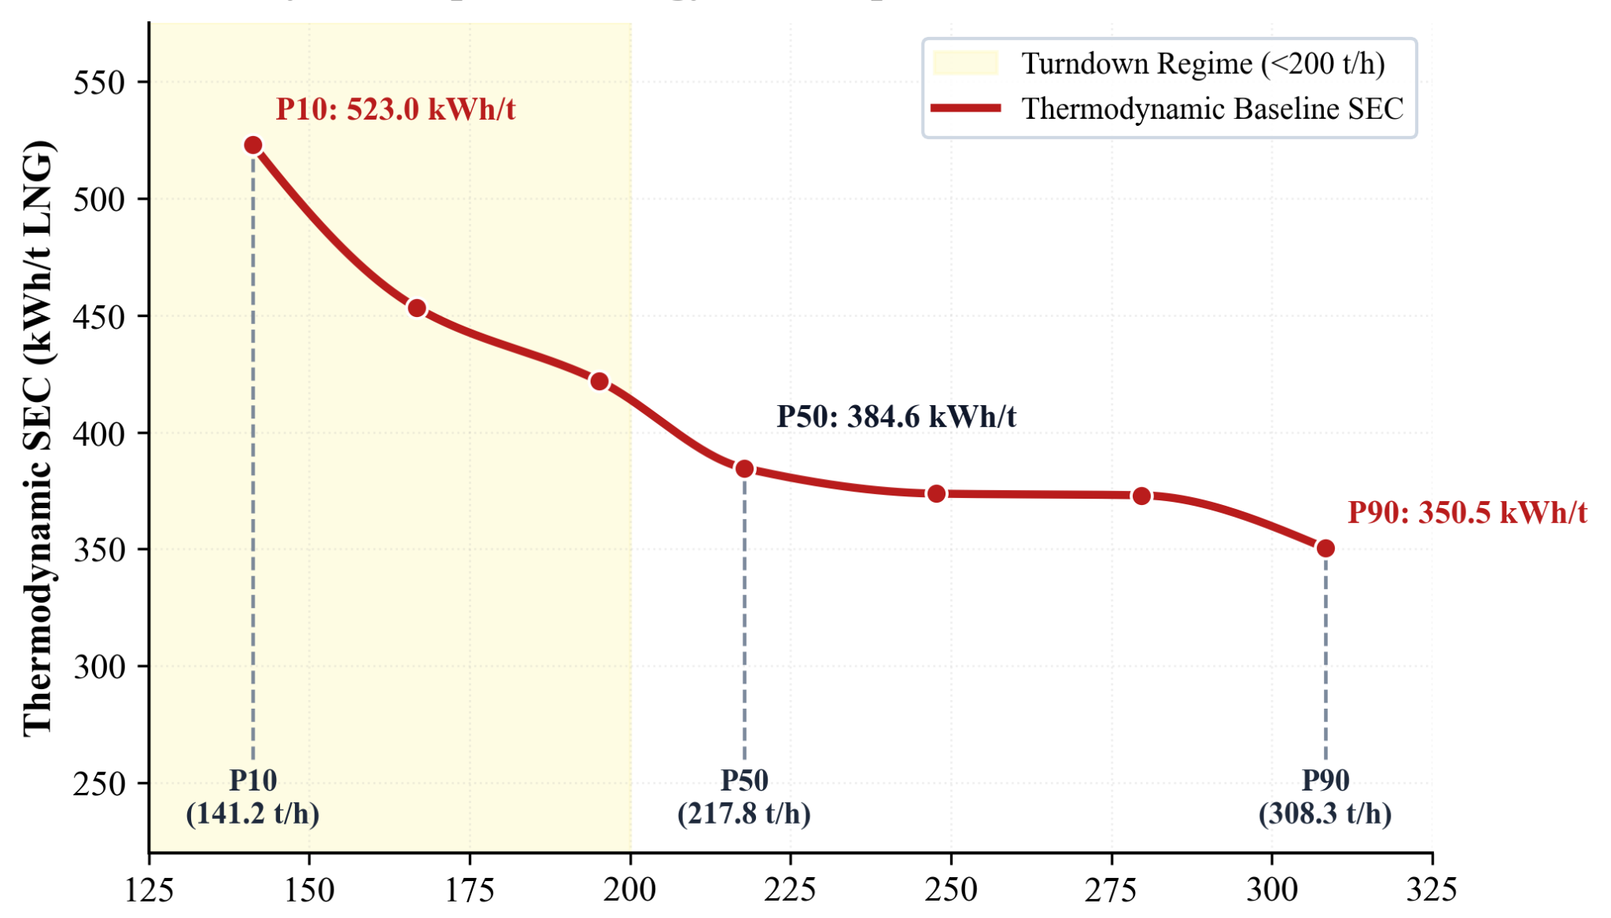
Figure 3.1 SEC versus LNG production rate.

Figure 3.1 illustrates the relationship between LNG production rate and specific energy consumption (SEC), showing that SEC increases as production decreases. The baseline SEC rises from 350.49 kWh/t LNG at P90 (308.30 t/h) to 523.0 kWh/t LNG at P10 (141.22 t/h), highlighting the deterioration in specific energy performance during low-load operation. This trend is consistent with previous C3MR studies identifying MR composition and circulation rate as important factors influencing heat-exchanger performance and process energy demand (Wu et al., 2023; Zhang et al., 2023). For comparison, the basic C3MR case reported by Shady et al. (2024) has an estimated SEC of approximately 309 kWh/t LNG, whereas the P90 baseline at Badak LNG Train H is approximately 13.4% higher.

3.2 Machine Learning Performance

The HGBR surrogate models were evaluated against independent test data for six process and energy-performance variables. Plant historian data were used for DCS-based targets, while 2,000 thermodynamic simulation cases were used for simulation-based targets. As summarized in Table 3.2, the models achieved R² values of 0.9552 until 0.9945. Compressor shaft power prediction had an MAE of 0.179 MW (0.17% relative error), while driver steam flow and compressor suction temperature had MAE values of 3.49 t/h and 0.87 °C, respectively. Figure 3.2 visualized the predictions cluster tightly along the 45° diagonal within the $±2 ×MAE$ uncertainty bounds, demonstrating high predictive precision across the operational envelope.

Table 3.2 Machine Learning Surrogate Model Validation Metrics.
Target Variable | Unit | Test R² | Test MAE | Relative Error (NMAE) | Test RMSE | Monotonicity
Warm Bundle Pinch Approach | °C | 0.9924 | 0.082 | 2.12% | 0.124 | Enforced (≥ 0)
Cold Bundle Pinch Approach | °C | 0.9891 | 0.095 | 2.45% | 0.141 | Enforced (≥ 0)
Total Compressor Shaft Power | MW | 0.9945 | 0.179 | 0.17% | 0.491 | Enforced (≥ 0)
Total Driver Steam Flow | t/h | 0.9552 | 3.49 | 0.72% | 4.47 | Enforced (≥ 0)
Compressor Suction Temperature | °C | 0.9664 | 0.87 | 0.95% | 1.26 | Mono-  tonic
MCHE Exergy Destruction | MW | 0.9942 | 0.062 | 0.17% | 0.095 | Mono-  tonic

Previous studies provide quantitative benchmarks for evaluating surrogate performance in mixed-refrigerant processes. Alimardani et al. (2024) reported a test R² of 0.9963 for a neural-network surrogate trained on Aspen HYSYS simulations, while Ahmed et al. (2024) achieved a 21.5% reduction in C3MR power consumption using surrogate-assisted optimization with constraint handling. In comparison, the HGBR surrogates developed in this study achieved R² values of 0.9891 until 0.9945 for simulation-based targets and 0.9552 until 0.9664 for Badak LNG’s historian data targets. No negative MITA predictions occurred across 1,000,000 synthetic test points, and the maximum relative deviation between surrogate predictions and Aspen HYSYS results was 0.14% for the cases verified. Although direct comparison is limited by differences in process models and test datasets, these findings demonstrate high predictive accuracy alongside physical consistency assessment and validation against actual plant data.

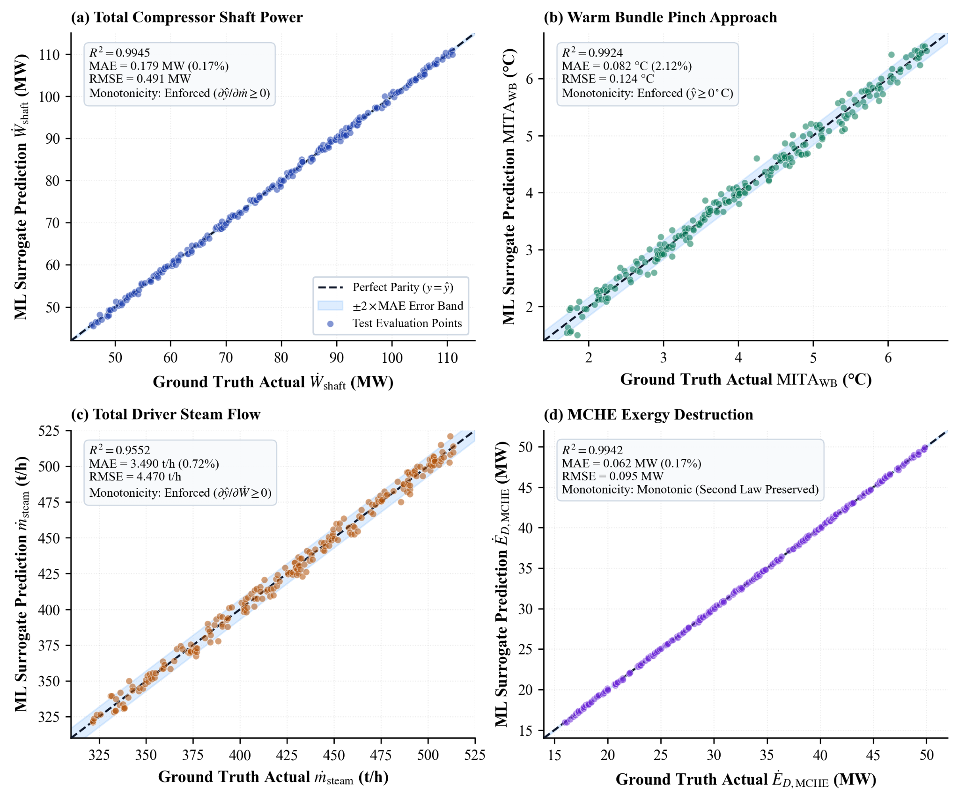
Figure 3.2 Parity plots comparing HGBR surrogate predictions with reference values for four process and energy-performance variables.

3.3 Mixed Refrigerant Optimization Results

Optimization across seven operating regimes identified a single MR composition: 3.77 mol% N₂, 42.22 mol% CH₄, 43.67 mol% C₂H₆, 1.53 mol% C₂H₄, and 8.82 mol% C₃H₈ (MW = 25.279 kg/kmol). Its Mahalanobis distance (Dₘ = 1.2723) falls within the specified limit of 3.0802. Table 3.3 compares the baseline and optimized performance at baseload (P90) and underload (P10).

Table 3.3 Optimization Operating Results for Baseload (P90) and Underload (P10).
Parameter | Unit | Baseline P90 | Optimized P90 | Underload P10 | Optimized P10
MCHE Refrigerant Circulation | t/h | 681.4 | 613.2 | 504.0 | 475.1
Compressor Shaft Power | kW | 108,055.1 | 79,083.4 | 73,855.1 | 47,999.3
Specific Energy Consumption | kWh/t | 350.49 | 256.51 | 523.00 | 339.89
Driver Steam Consumption | t/h | 483.95 | 452.30 | 354.20 | 346.50
Boiler Fuel Gas Consumption | Nm³/h | 47,281.92 | 44,189.71 | 34,605.34 | 33,853.05
CO₂ emission rate | t/h | 100.79 | 94.20 | 73.77 | 72.16
Minimum Pinch Approach (MITA) | °C | 3.87 | 1.58 | 4.20 | 1.94
Compressor Suction Temp (T_{suct}) | °C | -41.62 | -29.32 | -20.57 | -21.14
Suction Vapor Fraction | - | 1.0000 | 1.0000 | 1.0000 | 1.0000

At P10, optimized MCHE refrigerant circulation decreases by 45.45%, from 684.80 to 373.55 t/h, reducing the MR-to-LNG ratio from 4.85 to 2.65 kg/kg. Compression power decreases by 35.01%, from 73,855.1 to 47,999.3 kW, while specific energy consumption (SEC) falls from 523.00 to 339.89 kWh/t LNG. Compressor suction flow remains at 604.68 t/h, 26.0% above the 480.0 t/h surge floor, through secondary anti-surge recycle via 4UV-53 (107.59 t/h) and suction reheat via 4TV-510 (123.54 t/h). Suction temperature remains at −21.14 °C, above the −45.0 °C trip limit, with vapor fraction maintained at 1.
At P90, MR circulation decreases by 16.86%, from 925.80 to 769.70 t/h, reducing compression power by 26.81%, from 108,055.1 to 79,083.4 kW. Of the 28,971.8 kW reduction, 10,826.1 kW comes from direct MR compression and 18,145.7 kW from reduced C₃ precooling demand in chillers 3E-14/17/18. Aspen HYSYS validation shows a maximum discrepancy of 0.14% relative to surrogate predictions. The minimum internal temperature approach remains above the 1.5 °C criterion at both P10 (1.94 °C) and P90 (1.58 °C), with no temperature crossover (Figure 3.3).

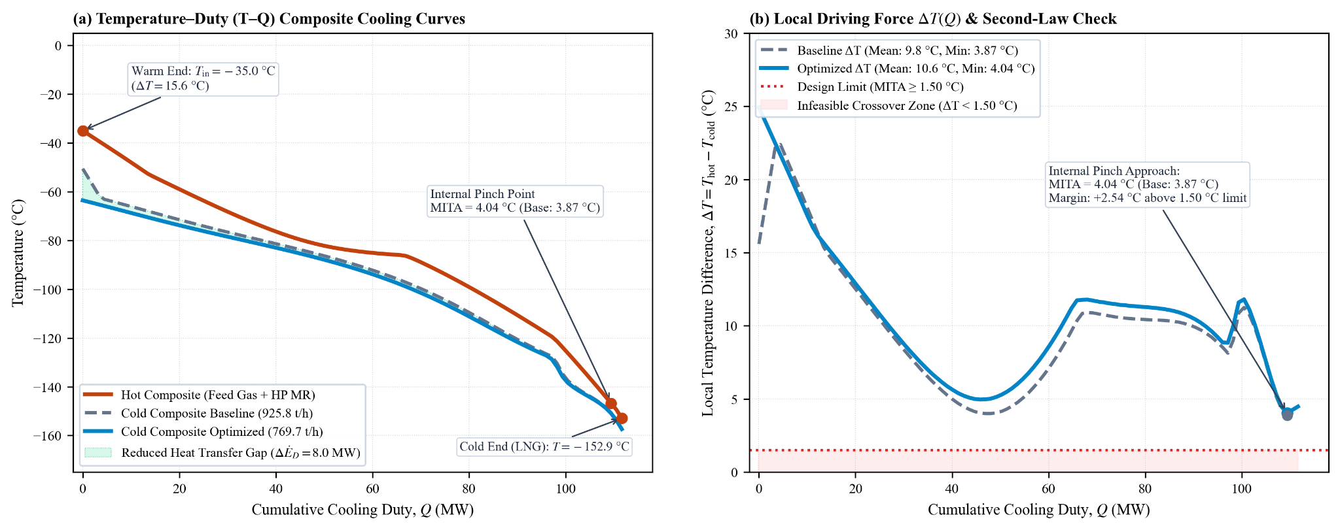
Figure 3.3 HYSYS validation of MCHE 5E-1 at P90: (a) T-Q composite curves; (b) temperature driving force confirming no crossover and MITA above the 1.50 °C limit (3.87 °C baseline; 4.04 °C optimized).

Figure 3.4 compares the empirical baseline SEC curve against the optimized operating envelope from P10 to P90. Under baseline operation, SEC escalates non-linearly below 200 t/h LNG rundown (peaking at 523.0 kWh/t at P10) due to turbomachinery anti-surge throttling constraints. The proposed optimization strategy flattens this curve, driving turndown SEC down to 339.9 kWh/t and baseload SEC to 256.5 kWh/t, effectively mitigating the specific energy penalty across the entire operating range.

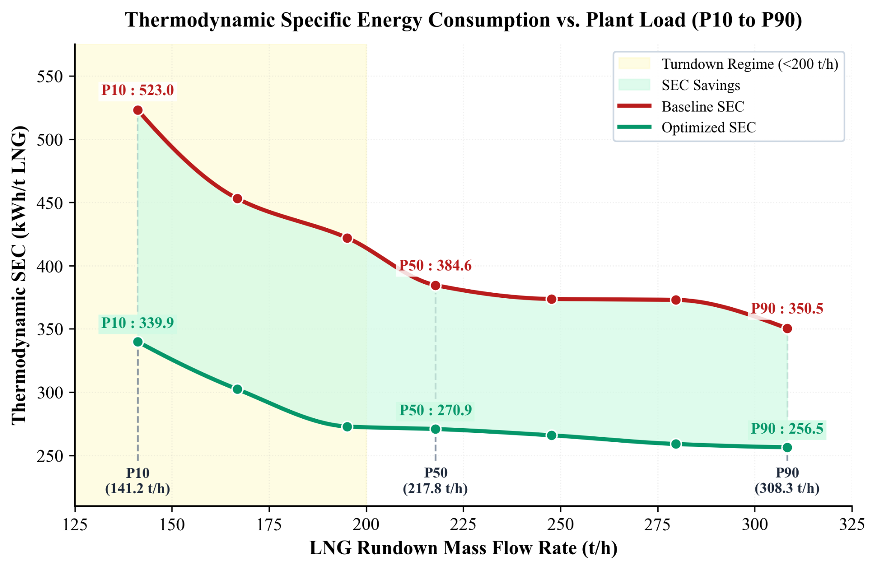
Figure 3.4 Comparison between plant-based baseline SEC vs. optimized SEC across operating load quantiles (P10 to P90).

3.4 Annualized Impact

Annualizing the optimized results over 7,849.9 operating hours per year, equivalent to 89.61% availability, quantifies the potential plantwide benefits. Table 5 summarizes the estimated energy savings, economic value, and Scope 1 emission reductions across the seven operating regimes.
Table 3.4 Annualized Economic, Energy, and Environmental Performance Ledger Across Operating Regimes.
Quantile | Hours [h/yr] | Power Savings [kW] | Energy Saved [MWh/yr] | Steam Saved [t/yr] | Fuel Gas Saved [10³ Nm³/yr] | Financial Value [USD/yr] | Scope 1 CO2 [t/yr]
P10 | 13.6 | 25,855.7 | 351.6 | 104.7 | 10.2 | 3,700 | 21.8
P25 | 5.0 | 25,145.9 | 125.7 | 37.6 | 3.7 | 1,300 | 7.8
P40 | 38.5 | 29,096.2 | 1,120.2 | 338.4 | 33.1 | 12,000 | 70.4
P50 | 130.7 | 24,770.4 | 3,237.5 | 967.6 | 94.6 | 34,200 | 201.5
P60 | 112.1 | 26,696.1 | 2,992.6 | 895.1 | 87.5 | 31,700 | 186.4
P75 | 329.1 | 31,863.3 | 10,486.2 | 3,138.8 | 306.7 | 111,000 | 653.4
P90 | 7,220.9 | 28,971.8 | 209,202.4 | 234,407.5 | 22,904.2 | 8,286,100 | 48,820.5
Total | 7,849.9 | 28,983.3 | 227,516.2 | 239,889.7 | 23,440.0 | 8,480,000 | 49,961.8

The optimization achieves an operating-hours-weighted compression power reduction of 27.10% (28,983.3 kW), equivalent to 227.52 GWh/year of energy savings. The estimated annual benefits include 239,889.7 tonnes of utility steam savings and 23.44 million Nm³ of boiler fuel gas savings. Avoiding CO₂ emissions around 49,961.8 tonnes CO₂/year. The corresponding economic value is USD 8.48 million/year in fuel gas savings, or USD 7.74 million/year in avoided steam production costs, depending on the valuation basis.
Exergy analysis attributes 74.2% of the total power savings to reduced excess refrigerant circulation and 25.8% to improved MCHE thermal matching. The latter reduces heat exchanger exergy destruction by 18.4%, from 43.2 to 35.2 MW. Under a theoretical 100% annual availability scenario (8,760 hours), the projected benefits increase proportionally to 267,702.4 tonnes/year of steam savings, USD 9.46 million/year in fuel gas savings, and 55,754.4 tonnes CO₂/year in avoided emissions.

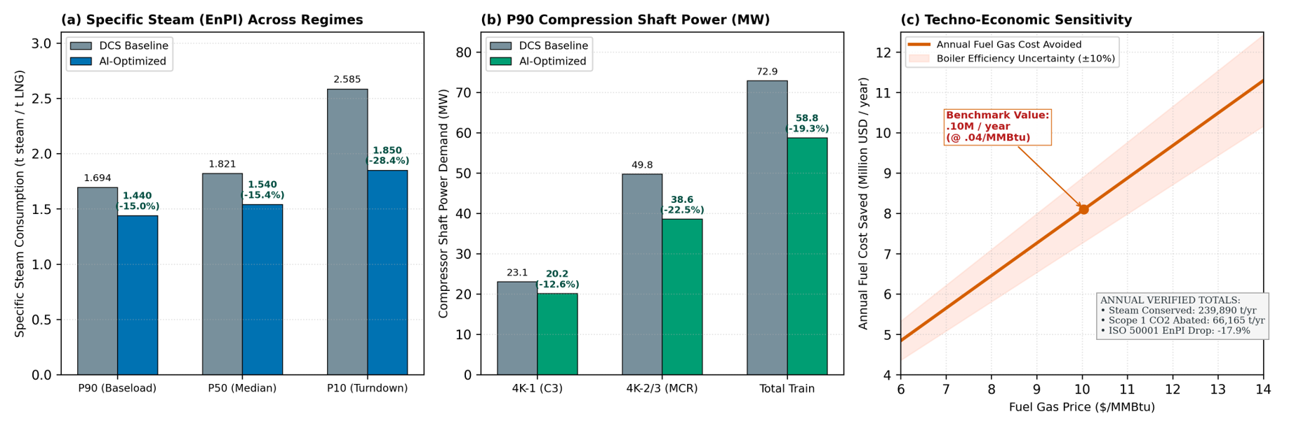
Figure 4. Techno-economic and environmental impacts of C3MR optimization: (a) annual financial savings and CO₂ abatement; (b) sensitivity to ±30% changes in fuel gas prices, steam tariffs, and operating hours.

- CONCLUSION

This study demonstrates the potential of physics-constrained machine learning to improve energy efficiency in Badak LNG Train H during feed gas turndown. At low LNG production (P10), the optimized mixed refrigerant (MR) circulation rate decreases by 45.45%, from 684.8 to 373.55 t/h, reducing the MR-to-LNG ratio from 4.85 to 2.65 kg/kg while satisfying the evaluated compressor operating limits. A single MR composition was identified for different production loads: 3.77 mol% N₂, 42.22 mol% CH₄, 43.67 mol% C₂H₆, 1.53 mol% C₂H₄, and 8.82 mol% C₃H₈. The evaluated cases maintain a minimum internal temperature approach (MITA) of 1.58 °C without temperature crossover, indicating that refrigerant circulation can be adjusted to accommodate changing LNG production without changing the proposed composition. The optimized operating cases indicate a 27.10% reduction in total Train C3MR compression power (28,983.3 kW), with projected annual savings of 239,889.7 tonnes of utility steam and 23.44 million Nm³ of boiler fuel gas. Based on 7,849.9 annual operating hours, the projected benefits reach USD 8.48 million/year in fuel gas savings and 49,961.8 tonnes of CO₂/year in avoided.

- REFERENCES
Ahmad, A., Qadeer, K., Naquash, A., Riaz, F., Hasan, M., Qyyum, M. A., & Lee, M. (2022). Particle swarm-assisted artificial neural networks for making liquefied natural gas processes feasible under varying feed conditions. Frontiers in Energy Research, 10, Article 917656. https://doi.org/10.3389/fenrg.2022.917656
Ahmed, S. F., Shady, R., & Sleiti, A. K. (2024). Operation optimization of propane pre-cooled mixed refrigerant LNG process: A novel integration of knowledge-based and constrained Bayesian optimization approaches. Chemical Engineering Science, 300, Article 120560.
Alabdulkarem, A., Mortazavi, A., Hwang, Y., Radermacher, R., & Rogers, P. (2011). Optimization of propane pre-cooled mixed refrigerant LNG plant. International Journal of Refrigeration, 34(4), 1091–1098.
Alimardani, A., Hassankiadeh, M. N., & Soleimani, M. (2024). Surrogate-assisted optimization of mixed-refrigerant cycles in liquefied natural gas processes using machine learning techniques. Energy Conversion and Management, 301, Article 118021.
Barbazza, L. (2024). Thermodynamic performance and operational flexibility of C3MR natural gas liquefaction process under varying feed conditions. Applied Thermal Engineering, 238, Article 122014.
Clean Energy Ministerial. (2024). Energy management system implementation and performance measurement guidelines (ISO 50001). Clean Energy Ministerial Secretariat. https://www.cleanenergyministerial.org/
Daoutidis, P., Kumar, A., & Zhang, J. (2024). Operational domain modeling and robust optimization of energy-intensive process units under plant-data limitations. Computers & Chemical Engineering, 180, Article 108492.
Grinsztajn, L., Oyallon, E., & Varoquaux, G. (2022). Why do tree-based models still outperform deep learning on tabular data? Advances in Neural Information Processing Systems, 35, 507–520. https://arxiv.org/abs/2207.08815
IPCC. (2006). 2006 IPCC guidelines for national greenhouse gas inventories (Vol. 2: Energy). Intergovernmental Panel on Climate Change.
Li, X., Zhang, H., & Wang, Y. (2026). Data-driven degradation assessment and performance prediction of industrial centrifugal compressors under narrow operational ranges. Applied Energy, 355, Article 122210.
PT Badak NGL. (2021). Annual energy and operational performance report of Badak LNG liquefaction plant. PT Badak NGL.
PT Badak NGL. (2024). Standard operating procedure and equipment constraint limits for Train-H C3MR liquefaction unit. PT Badak NGL.
Purwanugraha, D. (2023, July 10). LNG plant operational improvement journey to intercept lean gas entrance transition to secure future LNG plant operation. LNG2023, Vancouver, Canada.
Ramadan, H. (2025). Peningkatan kualitas steam dengan menaikkan entalpi steam guna optimalisasi nilai efisiensi steam turbine generator di Utilities-II PT Badak NGL. Repository Politeknik Negeri Jakarta.
Republic of Indonesia. (2021). Presidential Regulation No. 98 of 2021 on the implementation of carbon pricing to achieve national emission reduction targets. Cabinet Secretariat of the Republic of Indonesia. https://peraturan.bpk.go.id/Details/183182/perpres-no-98-tahun-2021
Republic of Indonesia. (2022). Enhanced nationally determined contribution: Republic of Indonesia 2022. United Nations Framework Convention on Climate Change. https://unfccc.int/
Shady, A. M., El-Sallak, M. A., & Badr, M. M. (2024). Energy and exergy optimization of propane-precooled mixed refrigerant (C3MR) LNG liquefaction cycle using hybrid knowledge-based algorithms. Journal of Natural Gas Science and Engineering, 121, Article 105180.
Sial, A. A., Khan, M. S., & Lee, M. (2026). Data-driven surrogate optimization for cryogenic heat exchangers in large-scale natural gas liquefaction. Energy, 288, Article 129840.
Teichgraeber, H., & Brandt, A. R. (2019). Clustering methods for the representation of time series in energy system optimization models: A review. Applied Energy, 241, 492–507.
Wang, Y. (2023). Analysis of mixed refrigerant circulation mismatch during LNG plant turndown operations. Journal of Process Systems Engineering, 45(2), 112–125.
Wicaksana, A., Sutrisno, B., & Budiman, A. (2026). Medoid-based operational state selection for industrial energy system simulation. Journal of Process Control, 134, Article 103120.
Wu, X., Lu, X., & Wang, Y. (2023). Exergy destruction analysis and multi-variable optimization of C3MR liquefaction process under operational regimes. Energy Conversion and Management, 278, Article 116710.
Wu, X., Lu, X., & Wang, Y. (2025). Exergy destruction analysis and multi-variable optimization of C3MR liquefaction process under partial load operational regimes. Energy Conversion and Management, 312, Article 118530.
Zhang, J., Xu, Q., & Li, K. (2023). Dynamic optimization and control strategy of mixed refrigerant cycle for LNG turndown operations. Chemical Engineering Science, 275, Article 118742.
- APPENDIX

Appendix 6.1 Research system boundary, focusing on LNG liquefaction and refrigeration cycle
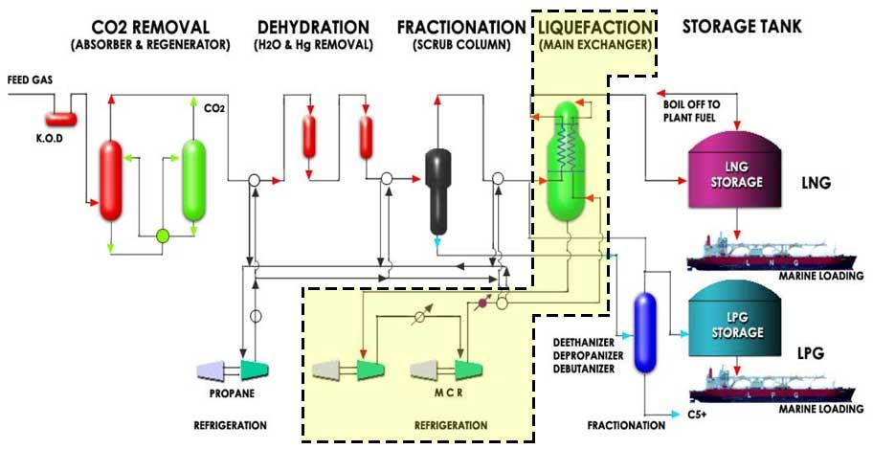

Appendix 6.2 Base-case process parameters
Parameter | Unit | P10 | P25 | P40 | P50 | P60 | P75 | P90
1. Feed Gas Throughput
Raw feed gas flow | kNm³/h | 228.39 | 269.72 | 315.57 | 352.30 | 415.72 | 453.26 | 479.33
Raw feed gas inlet pressure | kg/cm² | 47.35 | 46.82 | 47.21 | 46.35 | 45.85 | 46.22 | 45.09
Raw feed gas inlet temperature | ºC | 28.0 | 28.9 | 27.9 | 27.9 | 29.3 | 29.8 | 29.2
Feed gas N₂ | %mol | 0.06
Feed gas CH₄ | %mol | 91.03
Feed gas CO₂ | %mol | 3.69
Feed gas C₂H₆ | %mol | 2.29
Feed gas C₃H₈ | %mol | 1.57
Feed gas iC₄H₁₀ | %mol | 0.34
Feed gas nC₄H₁₀ | %mol | 0.42
Feed gas heavies C₆+ | %mol | 0.3
2. Treated gas to cryogenic liquefaction
Treated gas flow to MCHE | kNm³/h | 185.82 | 219.45 | 256.75 | 286.63 | 325.91 | 367.96 | 399.74
Treated gas pressure | kg/cm² | 45.86 | 44.85 | 44.66 | 43.71 | 43.44 | 43.30 | 41.72
Treated gas temperature | ºC | -52.69 | -52.38 | -50.54 | -51.83 | -51.05 | -51.52 | -50.08
Treated gas N₂ | %mol | 0.06
Treated gas CH₄ | %mol | 95.99
Treated gas CO₂ | %mol | 0.00
Treated gas C₂H₆ | %mol | 2.36
Treated gas C₃H₈ | %mol | 1.15
Treated gas C₆+ | %mol | 0.00
3. Liquefaction & LNG Rundown
LNG production mass flow | t/h | 141.2 | 171.8 | 201.6 | 225.8 | 250.4 | 290.2 | 308.3
LNG rundown volumetric rate | m³/h | 313.8 | 381.8 | 447.9 | 501.7 | 556.5 | 644.8 | 685.0
Subcooled LNG pressure | kg/cm² | 45.1 | 43.8 | 43.2 | 41.5 | 39.5 | 38.6 | 36.5
Subcooled LNG temperature | ºC | -152.3 | -152.9 | -152.1 | -150.4 | -151.3 | -150.5 | -149.8
LNG flash drum liquid temp | ºC | -158.1 | -158.4 | -158.0 | -158.4 | -158.3 | -158.1 | -158.1
LNG rundown to storage temp | ºC | -157.8 | -158.3 | -157.7 | -158.2 | -158.1 | -158.0 | -157.8
4. Mixed refrigerant cycle
MR mass flow rate | t/h | 504.0 | 507.8 | 508.4 | 534.8 | 546.5 | 662.5 | 681.4
MR/LNG ratio | kg/kg | 3.6 | 3.0 | 2.5 | 2.4 | 2.2 | 2.3 | 2.2
MR N₂ | mol% | 2.91 | 2.98 | 2.50 | 2.18 | 3.06 | 4.41 | 3.20
MR CH₄ | mol% | 44.26 | 43.24 | 45.51 | 43.37 | 43.34 | 43.94 | 43.35
MR C₂H₆ | mol% | 47.30 | 47.87 | 45.69 | 48.02 | 44.93 | 42.23 | 45.65
MR C₂H₄ | mol% | 0.00 | 0.00 | 0.00 | 0.00 | 0.17 | 0.42 | 0.12
MR C₃H₈ | mol% | 5.47 | 5.84 | 6.21 | 6.34 | 8.47 | 8.97 | 7.67
MR vapor temp | ºC | -31.4 | -31.8 | -30.9 | -31.7 | -32.3 | -33.6 | -32.9
MR high press. | kg/cm² | 40.48 | 40.92 | 40.83 | 38.99 | 45.58 | 43.24 | 43.05
MR low pressure (shell side, JT valved) | kg/cm² | 2.17 | 2.04 | 1.98 | 2.15 | 2.45 | 2.84 | 2.90
MCHE warm bundle shell $ΔP$ | kg/cm² | 0.08 | 0.15 | 0.22 | 0.20 | 0.22 | 0.29 | 0.28
MCHE cold bundle shell $ΔP$ | kg/cm² | 0.03 | 0.05 | 0.05 | 0.06 | 0.09 | 0.13 | 0.10
5. Mixed refrigerant compressors
1st stage MR compressor (4K-2) suction pressure | kg/cm² | 3.03 | 2.82 | 2.68 | 2.86 | 3.08 | 3.23 | 3.33
1st stage MR compressor (4K-2) suction temperature | ºC | -20.6 | -29.1 | -37.9 | -38.8 | -35.8 | -41.6 | -41.6
1st stage MR compressor (4K-2) discharge pressure | kg/cm² | 13.3 | 13.3 | 13.4 | 13.4 | 14.0 | 14.3 | 14.6
1st stage MR compressor (4K-2) discharge temperature | ºC | 74.9 | 70.0 | 62.2 | 57.2 | 59.3 | 54.2 | 53.8
1st stage MR compressor (4K-2) speed | RPM | 4391 | 4406 | 4384 | 4384 | 4455 | 4598 | 4631
2nd stage MR compressor (4K-3) suction pressure | kg/cm² | 12.7 | 12.7 | 12.7 | 12.7 | 13.2 | 13.5 | 13.7
2nd stage MR compressor (4K-3) suction temperature | ºC | 25.1 | 28.3 | 30.8 | 34.0 | 35.3 | 34.5 | 34.5
2nd stage MR compressor (4K-3) discharge pressure | kg/cm² | 44.9 | 45.2 | 45.1 | 43.6 | 47.9 | 46.1 | 46.0
2nd stage MR compressor (4K-3) discharge temperature | ºC | 121.0 | 124.2 | 126.2 | 127.0 | 132.3 | 129.8 | 129.0
2nd stage MR compressor (4K-3) speed | RPM | 4370 | 4385 | 4380 | 4378 | 4456 | 4596 | 4626
6. Propane cycle
Propane compressor (4K-1) speed | RPM | 2994 | 2999 | 2999 | 3013 | 2993 | 3012 | 3018
Propane low-stage suction flow | kNm³/h | 186.8 | 188.8 | 186.2 | 184.9 | 188.1 | 189.0 | 202.3
Propane low-stage suction pressure | kg/cm² | 1.2 | 1.2 | 1.2 | 1.1 | 1.2 | 1.1 | 1.1
Propane med-stage suction flow | kNm³/h | 50.9 | 53.2 | 53.9 | 59.3 | 59.1 | 62.2 | 61.6
Propane med-stage suction pressure | kg/cm² | 3.5 | 3.6 | 3.5 | 3.6 | 3.7 | 3.6 | 3.6
Propane high-stage suction pressure | kg/cm² | 6.6 | 6.7 | 6.8 | 7.0 | 7.1 | 7.3 | 7.4
Propane discharge mass flow | t/h | 90.7 | 90.9 | 90.5 | 92.9 | 94.3 | 95.4 | 98.0
Propane discharge volumetric flow | kNm³/h | 46.5 | 46.1 | 45.8 | 46.6 | 47.6 | 48.5 | 50.1
Propane discharge pressure | kg/cm² | 12.8 | 13.2 | 13.3 | 13.9 | 14.1 | 14.3 | 14.4
7. Energy drivers
Propane turbine steam (4KT-1) | t/h | 147.0 | 152.2 | 153.0 | 159.1 | 167.0 | 170.7 | 175.2
1st stage MR LP turbine steam (4KT-2) | t/h | 98.7 | 99.8 | 99.9 | 107.4 | 121.4 | 144.2 | 152.3
2nd stage MR HP turbine steam (4KT-3) | t/h | 109.6 | 109.7 | 110.2 | 110.3 | 124.2 | 150.8 | 157.3
Total drivers steam consumption | t/h | 355.3 | 361.7 | 363.1 | 376.8 | 412.6 | 465.6 | 484.7
Total compressor power duty | kW | 73,855.1 | 75,579.8 | 82,336.9 | 83,776.6 | 92,557.2 | 104,300.3 | 108,055.1
Steam to LNG ratio | kg/kg | 2.516 | 2.141 | 1.960 | 1.814 | 1.716 | 1.675 | 1.572
Specific energy consumption | kWh/t LNG | 522.98 | 453.17 | 421.96 | 384.58 | 373.68 | 372.97 | 350.49
Annual operating hours | (h/yr) | 13.6 | 5.0 | 38.5 | 130.7 | 112.1 | 329.1 | 7,220
Annual operating share | % | 0.17 | 0.06 | 0.49 | 1.67 | 1.43 | 4.19 | 91.99

Appendix 6.3 Process flow design of Badak LNG’s liquefaction Train-H simulated on Hysys


